User Stories Injection in Mongo DB

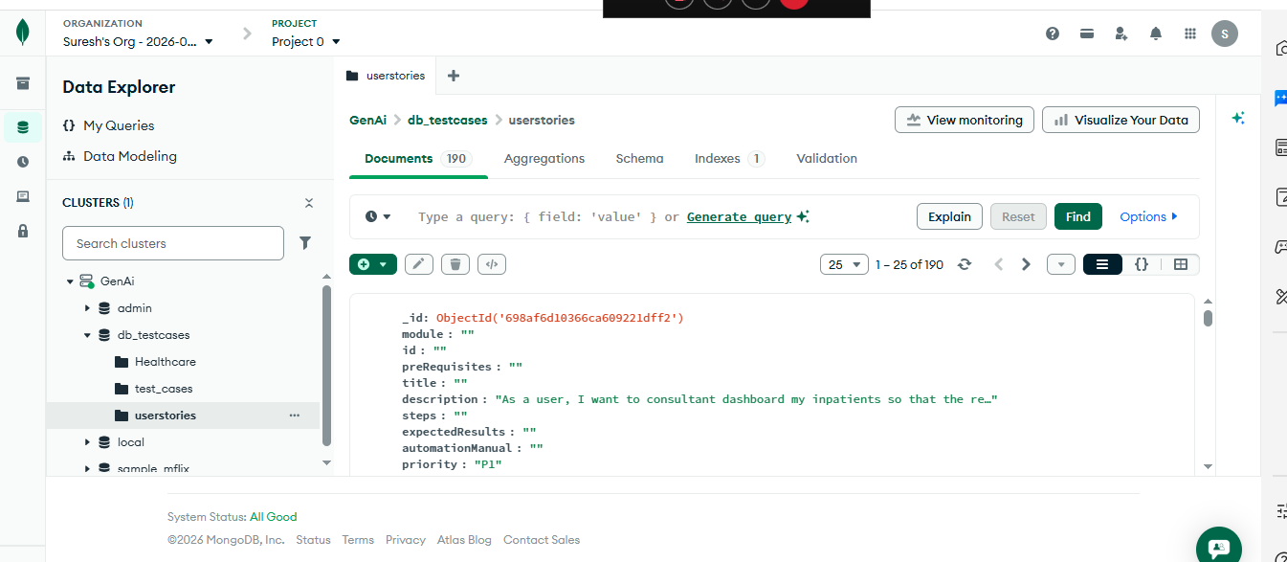

6352 Test cases injected in Mongo DB

